Ben
Weekly Relays User Guide
TOPICS LEGEND
 |  | WEEKLY RELAYS |  | July 13, 2017
YOUR DEPARTMENT NEWS |  |  | UTMB NEWS
OEA  Congratulations to Dr. Premal Patel who was recently inducted as one of the newest Scholars in the John P. McGovern Society for Oslerian Medicine.  Congratulations to Dr. Judith Rowen as well, who received the faculty medallion for the Osler Student Societies. |  |  | Best Care update:  UTMB has received its third-quarter performance report for the Vizient Quality & Accountability Study. Our overall ranking has improved to 8th place among the study’s participating 102 academic medical centers. For each category, our ranking is as follows:  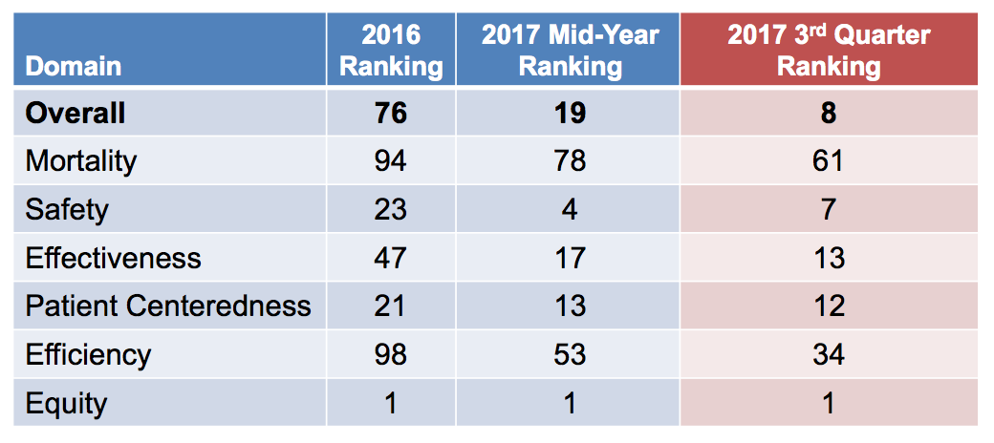  This is a testament to everyone’s commitment to providing Best Care to our patients. The final ranking will be available at the end of September 2017. As we close the year strong and maintain our rank, we must continue to focus on making UTMB a high-value practicing organization! Details are available at http://intranet.utmb.edu/best-care.  Temporary John Sealy Hospital walkway closure on the Galveston Campus:  The John Sealy Hospital Renovation will require a temporary closure of the covered pedestrian walkway on the north side of the hospital’s front entrance. This will occur on the evening of July 21 and last until July 25. The alternate route for people going to and from the Hospital Parking Garage area or Jennie Sealy Hospital will be the covered walkway on the north side of the building (near the John Sealy Annex). The closure will not affect patient pick-up/drop-off at John Sealy Hospital as the front entrance will remain open.  Patient pick-up/drop-off at UTMB Health Clinics to be relocated:  Beginning July 22, the patient pick-up/drop-off location in front of UTMB Health Clinics (UHC) on the Galveston Campus will temporarily be relocated to the adjacent ground-level Emergency Department Garage. This action is necessary to accommodate a crane and construction equipment that will be used to complete the future Biocontainment Unit (the unit is located within the Emergency Department). The construction will also impact traffic flow exiting the UHC/ED Garage (Garage 2). Please refer to the following link for more information https://utmb.us/20l. A notice that may be provided to patients (double-sided, in English and Spanish) can be downloaded at https://utmb.us/20m.
TOPICS  LEGEND | PATIENT CARE EDUCATION & RESEARCH INSTITUTIONAL SUPPORT CMC
AROUND UTMB (Use the legend above to quickly find items of interest to your team)
UTMB NEWS (continued)  ACTION ITEM: Annual benefits enrollment:  The annual enrollment period for the 2017–2018 benefits plan year is July 15 – 31. During this period, you may make changes to your benefits, add or remove dependents and/or enroll in a flexible spending account.  - You will need the personal identification number provided to you by the Office of Employee Benefits to access the My UT Benefits online system. Your PIN will be/was delivered by email on July 15.  - No action is necessary if you do not want to make any changes to your coverage for the upcoming plan year; however, employees interested in a flexible spending account must actively enroll each year.  - Your annual enrollment elections and new rates are effective Sept. 1, 2017.  See https://hr.utmb.edu/hrbbc/benefits/annual_enrollment/ for additional information, including an employee resource guide and a benefits cost worksheet.  ACTION ITEM: Annual compliance training:  All employees are required to complete annual compliance training by Aug. 31 based on their specific job duties and responsibilities. Please log in to the Enterprise Learning Management (ELM) system at https://hr.utmb.edu/tod/elm/ to ensure that all your assigned training and activities have been completed. Employees who do not finish their training by the institutional deadline will be suspended without pay until all requirements are met. For assistance with accessing the ELM system, see http://hr.utmb.edu/tod/elm/. Any questions or concerns about your compliance training may be directed to your manager or the Office of Institutional Compliance at (409) 747-8700.  ACTION ITEM: Annual employee evaluations:  The institutional deadline to complete annual evaluations for FY17 is July 31, 2017. An evaluation is required by UT System for all faculty and staff members hired on or before Feb. 28, 2017; however, anyone who received a formal evaluation after Jan. 1, 2017, does not need to be reviewed at this time. Employees are advised to speak with their leadership regarding any entity or department specific requirements and deadlines. For more annual evaluation information, see https://hr.utmb.edu/relations/performance/.  Health System Employee Engagement Survey:  UTMB Health is taking part in a survey conducted by the Houston Chronicle to determine the region’s top workplaces. As a member of the Health System or Academic Enterprise, you may have received an email invitation from WorkplaceDynamics, an independent research company, to complete this anonymous survey. Please take a few minutes to complete the survey and to share your thoughts about working at UTMB. The survey’s close date is July 21.  Offender Medical Pass:  Offenders should have a current copy of their Offender Medical Pass at all times. This document is provided at no charge to the offender. The official master pass for the patient is the Offender Medical Pass (with watermark and date/time stamp) printed from the Passes Module in Pearl and should be printed/issued to the offender any time orders have changed or upon request (if replacement is necessary). Provider/Nurses may print a copy of the Offender Medical Pass and issue to the offender at the time of ordering. Additionally, nursing and/or administrative staff may print a copy from the Passes Viewer on the Patient Summary Screen should the pass need to be printed at a later date or need to be replaced via SCR request, etc.  CMC data for June:  CMC leadership has started sharing the following metrics with all CMC employees via the Relay Notes:  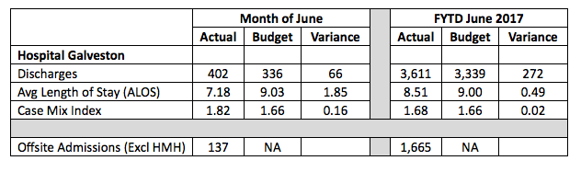  To reiterate, CMC would like HG discharges to increase, ALOS to decrease, CMI to increase and off-site admissions to decrease. |  |  | New for FY18 benefits plan year—UT Health Network:  Starting Sept. 1, UT SELECT Medical Plan participants will have access to a new benefit tier known as the UT Health Network. The UT Health Network features lower co-pays and co-insurance when receiving care from certain UT System physicians and medical facilities.  - Current: Copays $30 Primary/$35 Specialty and Coinsurance 80%  - New: Copays $20 Primary/$25 Specialty and Coinsurance 90%  This enhanced benefit is provided through the existing UT SELECT Medical Plan and does not require a special benefits election during the annual enrollment period. Please refer to the following link for more information: https://utmb.us/20t.  Information Services award:  UTMB was recently honored with a 2017 “Most Wired” Hospitals and Health Systems award from the American Hospital Association’s Hospitals Health Network Magazine. This designation is awarded for advancing information technology initiatives in areas of efficiency, patient engagement, population health and data analytics. For more information, visit http://www.hhnmag.com/mostwired.  Joint Commission reminders of the week:  - Bulk EKG electrode pads that are opened must be properly labeled with a 30-day expiration date.  - No food/drinks are allowed in nurses’ stations or clinical areas except for designated hydration stations (in which only beverages in spill proof containers are permitted).  - All O2 tanks should be properly stored; this includes:  - Securely in chains or holders  - Stored separately and labeled/tagged as full, in-use or empty
DID YOU KNOW?
UTMB is recognized by the Human Rights Campaign (HRC) as a 2017 Top Performer, achieving full credit in Non-Discrimination and Staff Training, Patient Services and Support, and Patient and Community Engagement. We are also mentioned in the 2018 Healthcare Equality Index (HEI) Resource Guide, which highlights best practices for HEI criteria. UTMB is committed to ensuring members of the Lesbian, Gay, Bisexual, Transgender and Queer (LGBTQ) community have access to information about health care issues, resources and initiatives that will benefit them and their families and offers LGBT patient navigation services. For more information, visit https://www.utmb.edu/health-resource-center/lgbtq-resources.

